(Narrow sense title) Thresholds to limiting similarity, width of competition and trait variance drive convergence and modularity in competitive networks

(Medium sense title) Thresholds to limiting similarity drive convergence and modularity in competitive networks

(Broad sense title) General drivers of trait convergence and modularity in competitive eco-evolutionary networks

Introduction

Interspecific competition often plays a central but potentially complex role in trait evolution (e.g Connell, 1980, Roughgarden, 1983; Schluter, 1994; Scheoner, 2006; Davies et.al., 2007). The common understanding is that competition, results in either exclusion or lowering of niche overlap through trait changes (Schluter, 1994). Theoretical literature predominantly supports the view that reduction in niche overlap though natural selection should result in divergence in traits of competing species (e.g. Reviewed in Abrams, 2000). Empirical studies have demonstrated these patterns using simple systems of pairwise interactions (for example, Taper, 1990; McGoey and Stitchcombe, 2009, Terhorst, 2011). The upshot is that an effect of competition is assumed to be in the form of trait divergence and observing limiting similarity or trait-overdispersion across communities or phylogenies is often taken as a signature of interspecific competition and (e.g. Losos,2008; Cavander-Bares et.al. 2009; Emerson and Gillespie, 2008).

However, limiting similarity is rarely demonstrated among species within a guild and trait distributions are often clumped (Examples in Scheffer and Van Nes, 2006; Kraft et.al.,2008). Recent increase in information about species interaction networks, has shown the prevalence of highly modular structures i.e. presence of strong interactions among subsets of species in communities (Montoya et.al., 2015; Dattilo et.al., 2013). Food webs or competitive networks with such structures indicate that species can have strong overlap in their resources and still coexist. Presence of such patterns are often attributed to alternative ecological or evolutionary processes and the effect of competition is assumed to be very weak or its effects are counter-acted by other factors.

Some theoretical studies have shown that species-rich communities subject to competition can evolve into groups of species with overlapping niches and similar traits although mostly focusing on dynamics of competitive exclusion (Roughgarden, 1974; Scheffer and Van Nes, 2006). It is hard to know when certain expectation is more realistic because it is difficult to attribute the conditions to the trend of either an overdispersion or a clumping of traits under competition (Abrams 1983). One important factor may be the mechanistic description of competition or the “competitive kernels” that relate differences in traits to intensity of competition between two individuals of different species. A prevalent family of models that describe trait-mediated competition use Gaussian functions for a competitive kernel (e.g. Abrams, 2000, Nuismer et.al. 2013). The Gaussian distribution is convenient to and it reflects the intuition behind limiting similarity, but it is also a continuous non-zero function and thus implies that all individuals in a community always compete to some extent even if they are very dissimilar. It often seems more realistic to consider that species no longer effectively compete once their traits differ beyond a certain point. For example, the mechanical fit between floral traits and proboscis lengths of nectar feeding bees will limit the number of plant species that nectarivores can visit, thus creating a stringent trait-difference threshold to competition between different bee species (Garibaldi et al., 2015; Newman, Manning, & Anderson, 2014, More´ et.al. 2012). Theoretical analysis of certain shapes of competitive kernels has shown that they may promote coexistence of clusters of similar competing species (Leimar et.al. 2013, Pigolotti et.al. 2010). Yet, the effect of sharp thresholds on the strength of competition as driver of modularity in competitive networks remain unknown. Since thresholds to competition affect the shape of the competitive kernel, they may influence the eco-evolutionary dynamics and promote the evolution of modularity and community stability.

To address this idea, we use a trait-matching model to simulate how competition affects the evolution of key traits in community assemblages (Abrams, 2000, Nuismer & Harmon, 2015; Barabás & D’Andrea, 2016). The model uses discrete generation Lotka-Volterra equations to describe population dynamics of a number of coexisting species. Population growth rates associated with different trait values provide a measure of absolute fitness, given density dependence and competition with all other species the assemblage. Intergenerational changes in mean trait values are calculated from these fitness differences using the breeder’s equation, assuming that heritable intraspecific variation follows the infinitesimal model of quantitative genetics (Barabás & D’Andrea, 2016; Barton, Etheridge, & Véber, 2017). By simulating population dynamics we account for the feedback between population dynamics and trait evolution. We therefore provide predictions about persistence of populations and communities with certain patterns in interaction network structure, as well as coevolutionary trends in trait values among the species in a model community.

In this study, we modified the Gaussian competition kernel using trait-difference competition thresholds of varying stringency. We systematically altered the width of the Gaussian curve thus creating competition kernels of different shapes. We also altered the levels of intraspecific trait variance, as it previously has been shown to influence dynamics of trait evolution. As we wanted to focus on evolutionary dynamics, the distributions from which demographic parameters were sampled were chosen to reduce the probability of extinction. We follow the evolutionary change in traits of species, as well as changes in characteristics of the network depicting interactions among species. We show that, when thresholds are more stringent and intraspecific trait variation is large, traits do not simply steadily diverge under competition, as is often assumed under competition. Instead, modular interaction networks and clustered trait distributions evolve that resemble those linked to greater stability of communities to disturbance. We propose that characterizing the shapes of competitive kernels in real communities will be critical to understanding the processes generating the community composition and community trait patterns at larger temporal scale.

**METHODS**

*Model description:*

The objective of this model is to describe trait and population dynamics of multiple competing species from same clade. We assume that in a community, populations of *n* species from one clade compete along a unidimensional axis of a single relevant trait; only the phenotypic value of interacting individuals determines the strength of the interspecific competition, not the species’ identity. Propagation of the chosen trait through generations is assumed to follow infinite loci model where each loci has an infinitesimal small contribution towards the trait value of an individual (Barton et al., 2017). This population genetics model predicts that the distribution of population’s trait values is normal, and its variance changes very little in response to selection. Therefore, each population is assumed to have its phenotypes normally distributed with mean µi and variance, 𝜎i2, where *i* denotes distinct species.

Growth rate or fitness of an individual with trait value z, under Lokta-Volterra dynamics is a function of the phenotype’s intrinsic growth rate in absence of any competition subtracted from the collective effect of all intra- and interspecific competitive interactions of co-occurring phenotypes. Growth rate (or fitness) of phenotype z of species i can be written as (Barabás & D’Andrea, 2016):

$w_{i}\left(z,t+1\right)=r_{i}−\frac{N_{i}\left(t\right)+\sum_{j≠i}{}\int{α\left(z,z^{'},t\right)p_{j}\left(z^{'},t\right)dz'}}{K_{i}}$

Where, pi(z,t), the trait distribution for species i, is assumed to be Normal with mean µi and variance $σ_{i}^{2}$:

$p_{i}\left(z,t\right)=\sqrt{\frac{1}{2πσ_{i}^{2}}}exp⁡\left(\frac{−{\left(z−µ_{i}\left(t\right)\right)}^{2}}{2σ_{i}^{2}}\right)$

ri is the intrinsic growth rate for species *i,* Ni is the population size of species i, Ki is the carrying capacity of species *i*, α, the coefficient of competition, is assumed to be a function of trait values of interacting individuals under the framework of trait-mediated interactions. The functional form of α is given as

$α\left(z,z'\right)=e^{\left(\frac{−{\left(z−z^{'}\right)}^{2}}{ω^{2}}\right)}$

Where, z and z’ are the phenotypic values of interacting individuals and ω is the width of the competition which determines the rate of decrease in interaction strength as the trait difference becomes larger (Barabás & D’Andrea, 2016; Nuismer & Harmon, 2015). It is a symmetric function which implies that the effect of competition on both participants would be identical. It also represents a continuous function of difference between traits, which means any two heterospecific individuals always compete regardless of their traits. To describe the effect that individuals should not compete if their traits are sufficiently different, we simply added a condition of a trait threshold to competition that can be modeled with a simple modification to the previous function:

$α\left(z,z'\right)=\{e^{\left(\frac{−{\left(z−z^{'}\right)}^{2}}{ω^{2}}\right),\left|z−z^{'}\right|≥t∗0,Otherwise}$

Where t* indicates a threshold difference between traits beyond which coefficient of competition is zero.

We can obtain a function for instantaneous growth rate for a population of each species by integrating trait-specific growth rates over the distribution of traits.

$\frac{dN_{i}}{dt}=N_{i}{r_{i}}/{K_{i}}\int{K_{i}−\sum_{j=1i≠j}^{n}{N_{j}\int{α\left(z,z^{'}\right)p_{j}\left(z^{'}\right)dz'}dz}}$

Additionally, the growth rate of an individual is also an absolute fitness of an individual. Based on this assumption we can combine the equation for the trait specific growth rates with the breeder’s equation, which provides the expression for response in mean traits to the selection differential on previous generation. As a result, the mean trait change for species i:

${\frac{dµ_{i}}{dt}=\frac{−h_{i}^{2}r_{i}}{K_{i}}\sum_{j=1i≠j}^{n}{N_{j}}\int{\int{\left(z−µ_{i}\right)α\left(z,z^{'}\right)}}p}_{i}\left(z\right)p_{j}\left(z^{'}\right)dzdz'$

Where, µi is the mean phenotype of the species *i,* and *hi* is the narrow sense heritability, which accounts for the genetic variation for additive genetic effects. Note that, under the infinitesimal quantitative genetic model, variance of population remains unchanged. Therefore, the expression for mean trait change alone provides the total evolutionary change in species under selection from intra- and inter-specific competition, with variance 𝜎i2.

*Parameters of interest:*

We focused on three parameters of this model that influence the trait dynamics of a given species: two of them, ω (width of competition) and t* (trait difference threshold to competition) describe the trait-matching model between competing individuals, determine the shape of the competition kernel (Fig. 1). Based on the formulation above we can observe that i) higher values of ω indicate stronger competition between individuals with given trait values, i.e. for higher values of ω, strength of competition decreases slower with trait difference, thus, imposing stronger selection pressure on competitors. ω values modulate the speed of the population and evolutionary dynamics. Also, lower ω values indicate stronger adherence to the trait-matching mechanism. ii) Threshold values, t*, dictate whether individuals compete or not based on their trait values. At the species level, t* means a neighborhood of competitors for a given species. The third parameter, $σ_{i}^{2}$, intraspecific trait variance, describes trait variance in the population of a given species. Intraspecific trait variation for a given species, $σ_{i}^{2}$, indicates the species’ response to selection pressure. Higher trait variance will lower the rate mean trait change for a given species. While the individual influence of these parameters on species’ trait evolution can be easily deduced, their collective impact on community level emergent properties is difficult to assess. Thus, we simulated population and trait dynamics of varying assemblages of competing species and assessed the influence of these three parameters on community level patterns.

*Simulating trait, population, and community dynamics*

For each initial assemblage of 20 or 50 species, we generated 60 distinct combinations of parameters by choosing following values for three parameters:1) Threshold to competition: either 5,7,10 or no threshold. 2) Intraspecific variability: For each species, the standard deviation for the trait distribution was chosen from one of the three uniform distributions - low: [0.5,1.5], high: [2.5,3.5], wide: [0.5,3.5]. 3) Width of competition: either 0.05, 0.1, 0.25,0.5 or 1. Higher value means a stronger negative impact of competition.

We incorporated these parameter combinations with 100 randomly chosen values of initial conditions for initial population size, carrying capacity and intrinsic growth rates. Initial population sizes for species were chosen from folded normal distribution with mean 1000 and standard deviation 500. Carrying capacities were set to be double of initial population sizes for respective species. Intrinsic growth rates were chosen from a folded normal distribution with mean 0 and standard deviation 0.5. Initial trait means are randomly sampled from a Normal distribution with mean 0 and standard deviation 5. Narrow sense heritability was fixed at 0.5. Values of trait means, and variabilities were chosen relative to the smallest value of the threshold to competition (5, in this case). In this way, we could get a large variation of initial networks structures.

Each simulation was run for 50000-time units. During the simulation, species whose populations went below zero were removed and labelled as ‘extinct’. Population and trait dynamics following the equations above were simulated in R.

**RESULTS**

**Sample outcome of a simulation:**

In all simulations, mean trait values broadly diverge over evolutionary time, with rates of change being fastest for roughly first 1000 generations and then slowing substantially (Fig.2-L1). There are some instances where mean traits of species cross early in the dynamic, but such crossings do not happen after the first 1000 generations. In the

simulation without any threshold (Fig.2-L1), all species appear to diverge uniformly in their traits, and the distribution of species trait values gradually become more evenly dispersed over time.

The addition of a threshold to competition qualitatively changes the evolutionary trends of species’ trait means (Fig.2-R1). Divergences between species become highly irregular, especially early in the transients. In some instances, the traits values of two or more species actually accelerate towards each other, eventually converging. This pattern causes the formation of multiple clusters of strongly interacting species with similar traits. Some of these clusters eventually lose member species as the overall trait range for the community gets wider, although in some cases these splits are ephemeral and the modules reform. In every case, clusters of 2-3 species persist to the end of the simulation at 50,000 generations. When this dynamic happens, modular interaction network structures emerge out of arbitrary initial assemblages of traits (Fig.2-R2), even though traits diverge on average among species overall.

**Network dynamics:**

Connectance decreases over time in all scenarios (Fig.3). When thresholds are absent (Fig. rightmost column panels), connectance values decrease slowest. They decrease faster as thresholds get narrower, and for lower values of ω (Fig 3, all panels). Different amounts of intraspecific variation do not seem to strongly alter the dynamics of connectance values however.

Thresholds, intraspecific variation and ω interact to create very diverse trends in modularity across scenarios (Fig.4). In the absence of thresholds, modularity always declines to a lower stable value within first 1000-2000 generations (Fig.4, rightmost column panels). This decline is particularly fast when intraspecific variation was high, and the final modularity almost reaches zero for all values of ω (Fig 4, rightmost column, bottom two panels). When intraspecific variation is low, the decline is slower and the final equilibrium modularity values are non-zero and positively related to ω (Fig 4j). Interestingly, that same pattern is in the presence of low intraspecific variation under all threshold scenarios (Fig 4, left three columns, first row).

Modularity evolves very differently when intraspecific variation is high and thresholds are narrower (t =5 and 7) (Fig 4, two leftmost columns and two bottom rows). In these cases, modularity initially increases rapidly and gradually decreases with time. When ω is lowest, this initial increase is steepest, reaching a relatively high modularity that remains stable until the end of the simulation. When ω is greater, this initial increase is modest because the initial modularity is already high to begin with, and modularity starts to decline from its maximum by the simulation’s end. For the broadest threshold value (t = 10), the dynamics are an amalgam of the patterns observed with narrow thresholds and without thresholds; an initial decrease in modularity is followed by a modest increase, before a final decrease. The value of ω is positively related to the speed of this dynamic; higher ω causes the initial decline, the following increase and the eventual decline to happen sooner.

**Trait dynamics:**

The trait spacing metric, MNND, is also strongly influenced by different combinations of parameter values (Fig.5). For the simulations with no threshold (Fig.5, rightmost column panels), MNND values rise sharply initially and reach the asymptote at 1 indicating perfectly even spacing. Higher values of ω accelerate the dynamics where MNNDs reach 1 quicker than those with lower ω values. High intraspecific variation for all the species (Fig.5, rightmost column, bottom two rows) cause this increasing trend to slow and an asymptote is reached much later.

Again, a very different trend is observed when the intraspecific variation values are high and the thresholds are narrow (t=5 and t=7) (Fig.5). MNND values sharply decrease compared to initial values and then gradually increase towards 1. Higher ω values accelerate these trends where the fall and the rise in MNNDs are much quicker.

Overall, our results show the combined role of the width of competition, trait difference threshold to competition and intraspecific trait variation on the emergence of modularity and coexistence in competitive networks. For values of X, Y, and Z, in the range of x, y and z, respectively, we show counter intuitive patterns with the emergence of clusters of species with converging trait values. On the other side, for values of X, Y, and Z in the range of x, y and z, respectively, our results show trait divergence and ... (here a paragraph summarizing the results to put reader’s mind in focus)

**Discussion:**

In this study, we determined whether imposing a trait threshold to interspecific competition influences the trait evolutionary dynamic of competing species. These trait thresholds represent functional constraints that prevent interactions between certain species. Instances of such functional constraints are well demonstrated in natural systems, especially in terms of species’s ability to feed on different resources (Garibaldi et al., 2015; Newman, Manning, & Anderson, 2014; Farias and Jaksic, 2007; Albrecht and Gotelli, 2001; Marti et.al. 1993, Chalcraft and Resetarits; 2003). Analytically, use of a Gaussian function, while efficient and intuitive, imposes a particular shape on the competition kernel. Use of trait thresholds drastically alters the shape of a competitive kernel and allows to see its effects on evolutionary dynamic. We deliberately seeded our simulations with trait distributions that ensured that species’ traits were very similar and thus they were competing strongly at first. We also chose a specific range of values for demographic variables that may reduce the chances of extinction, so as to enable us to observe the effects of competitive interactions on the evolution of traits. This scenario resembles the divergence of a clade of similar species evolving to exploit a wide niche space in a newly colonized habitat.

Our results show that introducing a simple threshold to competition can lead to highly diverse network structures and patterns of trait distributions to evolve in response to competition. In the absence of any trait threshold, where all species compete to some degree, we see classic divergence of traits. This pattern occurs even though there is some initial resorting of species in the simulations, which appears to result from using discrete generations that allow some species’ mean traits evolving quickly in response to stronger selection pressure to jump past the mean trait values of other species within individual time steps. However, when competition only exists between individuals whose traits are similar enough, we observed trait values of some pairs of species converge during the initial dynamics. All three of the parameters we varied – levels of intraspecific variation, trait threshold to competition and width of the competition kernel -- interact to affect the likelihood of observing such converging trait trajectories. These trends manifest at community scales as different dynamics in the variables characterizing community trait distribution and network structure (Fig.3,4,5,6).

As expected, connectance consistently decreased over time in all simulations as the initial range of trait values expanded due to an overall trend of traits diverging over time. The rate of decline in connectance depended only slightly on parameter values. When thresholds are absent (Fig.3 rightmost column panels), connectance values decrease slowest. They decrease faster as thresholds get narrower, and for lower values of ω (Fig 3, first, second and third column panels), because smaller differences in trait values are needed to break links between species in these scenarios. This generalized outcome agrees with empirical networks as well as other theoretical analyses, which show prevalence of low connectance in interaction networks (Allesina & Pascual, 2008; Allesina & Tang, 2011; DeAngelis, 1975; Rejmánek M. & Stary, 1979).

In contrast, modularity did not respond in a corresponding manner across all simulations. Greater values for modularity indicate the presence of strongly interacting clusters of species embedded in the larger network dominated by weak interactions. As species diverged in their trait values and compete less as observed in the absence of trait thresholds, we expected the modularity value to decline with time in all scenarios. However, when interspecific variation was large and trait thresholds were smaller modularity increased rapidly initially, as one might expect as some similar species converged in their traits over this time frame of first few hundred generations. The elevated modularity persisted for many generations, decreasing eventually since the modules that were formed initially, break apart. This trend was evident when the width of competition (ω) was high which caused a higher acceleration of the overall dynamics. Using principles of network theory, others have shown that weak interactions and high modularity render communities near equilibrium stable towards perturbations in antagonistic as well as mutualistic networks (Allesina & Tang, 2011; May, 1971, 1972). Our results suggest that it is possible for modular patterns to emerge out of an arbitrary community assembly and persist for significant time through simple competitive non-equilibrium eco-evolutionary dynamics.

The mean nearest neighbor distance (MNND), a measure of the evenness of the trait distribution, evolved in a way that combined the temporal patterns exhibited by connectance and modularity. As connectance decreased, the MNND tended to increase with time as expected given that species’ traits would generally diverge with time due to competitive interactions. However, in those scenarios where modularity increased during the initial dynamics, the MNND decreased, indicating that trait distributions became more clumped as modules formed. In communities, such clumped distributions are often taken to imply the importance other processes other than competition in structuring communities, such as environmental filtering, convergence toward fitness optima, or simple stochasticity. This clumped distribution was persistent for some time. MNND increased again markedly afterwards that indicated the further fragmentation of competing modules leading to more even trait distribution. High values of width of competition (ω) sped up this trend of initial decline in MNND and eventual increase towards the highest values. However, the lowest values of omega allowed clumped trait distributions to exist throughout the extent of the simulation.

Understanding what causes the formation of modules in our simulations may help us predict when to expect them in natural communities of competing species. In our model, interspecific competition is the only cause of trait evolution and net generational change in mean trait of any species is a linear combination of effects of all pairwise competitions. Also, if only two species with distinct trait means were to compete with each, their mean traits would never converge, irrespective of parameter values. Thus, in a multi-species assemblage of competitors, traits of two species adjacent on a trait axis will converge only if their mutual force of repulsion is overcome by the collective force of diffuse competition from rest of the competitors. Also, crucially, our model implies that two species with almost identical mean traits will have maximal impact on each other’s growth rates but not on each other’s trait evolution. There is a non-zero distance between species’ trait means that will effect biggest change in traits. This optimal distance depends on shape properties of a competitive kernel as well as intraspecific trait variation levels. Higher trait variation and stringent trait threshold will increase the likelihood convergent evolution in trait trajectories (see appendix!).

Higher likelihood of convergent trait trajectories induces more modular structures in competitive networks and clustered trait distribution. The association between parameter combinations and modularity of evolving networks is apparent in the heatmap in Figure 5. The mean modularity at the end of simulations increases sharply when the ratio of intraspecific trait variation to the threshold width gets to about 3.25 (3-3.5) or below (Fig. 6).

In a related model (Barabas and D’Andrea, 2016) competing species traits were found to converge if their intraspecific trait variation differed by certain amount, providing a measure of counterbalancing selection between the two species. However, this convergence only occurred when the two species were evolving toward a trait optimum. In our model, species converged and formed modules without such optima being present. Nonetheless, high intraspecific trait variation in our model would cause the competition kernel to have a shallower slope, as its shape is derived from the overlap between the trait distributions for the two competing species. Asymmetric competition from other species in the larger community could drive two similar species to converge in their trait values across this shallower gradient.

Our study solely focuses on how a symmetric interspecific competition described at the individual level can lead to trait and network patterns at the community level and over longer time scale. We did not address how additional external abiotic or biotic factors may combine or interact with competitive dynamics. Clearly, an integration of such factors may lead to different dynamics and patterns over community scale. Also, our model assumes that competitive interactions between all given species can be described using single key trait that is shared between competitors. However, multi-trait approach could be incorporated within our model framework and its impact on evolutionary dynamic can be assessed.

Despite these limitations, our results have two large implications for research on causes of trait distributions in extant communities, and what they say about the forces shaping community structure. First, the assumption that competition should always result in even trait distributions is too simple, and models that try to infer the role of competition in trait evolution using this assumption are subject to error under some conditions. Clustering has been shown in prior models of ecological and evolutionary processes when communities were initially saturated with species and allowed to prune through extinction. We show that such clustering arises from eco-evolutionary dynamics of arbitrarily assembled communities. Importantly, we also identify the conditions under which such patterns may arise in communities. Our research suggests that the qualitative shape of the competition kernel is key to understanding whether clustering or divergence results from the evolution of traits within communities of competing species. The shape of such kernels has rarely been characterized in natural communities. Such competitive kernels basically address mechanism behind how competition arises, and their shapes could capture the context specific to study systems. This could be addressed by analyses of resource utilization among consumer guilds and functional approaches that account for physical constraints on resource use.

References:

Abrams, P. (1983). The theory of limiting similarity. *Annual Review of Ecology and Systematics. Vol. 14*, *34*, 359–376.

Albrecht, M., & Gotelli, N. J. (2001). Spatial and temporal niche partitioning in grassland ants. *Oecologia*, *126*(1), 134–141. https://doi.org/10.1007/s004420000494

Allesina, S., & Pascual, M. (2008). Network structure, predator - Prey modules, and stability in large food webs. *Theoretical Ecology*, *1*(1), 55–64. https://doi.org/10.1007/s12080-007-0007-8

Barton, N. H., Etheridge, A. M., & Véber, A. (2017). The infinitesimal model: Definition, derivation, and implications. *Theoretical Population Biology*, *118*, 50–73. https://doi.org/10.1016/j.tpb.2017.06.001

Cavender-Bares, J., Kozak, K. H., Fine, P. V. A., & Kembel, S. W. (2009). The merging of community ecology and phylogenetic biology. *Ecology Letters*, *12*(7), 693–715. https://doi.org/10.1111/j.1461-0248.2009.01314.x

Dáttilo, W., Izzo, T. J., Vasconcelos, H. L., & Rico-Gray, V. (2013). Strength of the modular pattern in Amazonian symbiotic ant-plant networks. *Arthropod-Plant Interactions*, *7*(4), 455–461. https://doi.org/10.1007/s11829-013-9256-1

Emerson, B. C., & Gillespie, R. G. (2008). Phylogenetic analysis of community assembly and structure over space and time. *Trends in Ecology and Evolution*, *23*(11), 619–630. https://doi.org/10.1016/j.tree.2008.07.005

Farias, A. A., & Jaksic, F. M. (2007). Effects of functional constraints and opportunism on the functional structure of a vertebrate predator assemblage. *Journal of Animal Ecology*, *76*(2), 246–257. https://doi.org/10.1111/j.1365-2656.2006.01202.x

Garibaldi, L. A., Bartomeus, I., Bommarco, R., Klein, A. M., Cunningham, S. A., Aizen, M. A., Boreux, V., Garratt, M. P. D., Carvalheiro, L. G., Kremen, C., Morales, C. L., Schüepp, C., Chacoff, N. P., Freitas, B. M., Gagic, V., Holzschuh, A., Klatt, B. K., Krewenka, K. M., Krishnan, S., … Woyciechowski, M. (2015). Trait matching of flower visitors and crops predicts fruit set better than trait diversity. *Journal of Applied Ecology*, *52*(6), 1436–1444. https://doi.org/10.1111/1365-2664.12530

GRANT, P. R. (1972). Convergent and divergent character displacement. *Biological Journal of the Linnean Society*, *4*(1), 39–68. https://doi.org/10.1111/j.1095-8312.1972.tb00690.x

Jonathan Davies, T., Meiri, S., Barraclough, T. G., & Gittleman, J. L. (2007). Species co-existence and character divergence across carnivores. *Ecology Letters*, *10*(2), 146–152. https://doi.org/10.1111/j.1461-0248.2006.01005.x

Losos, J. B. (2008). Phylogenetic niche conservatism, phylogenetic signal and the relationship between phylogenetic relatedness and ecological similarity among species. *Ecology Letters*, *11*(10), 995–1003. https://doi.org/10.1111/j.1461-0248.2008.01229.x

May, R. M. (1972). Will a large complex system be stable? *Nature*, *238*, 413–414. https://doi.org/10.1038/238413a0

May, R. M. (1971). Stability in multispecies community models. *Mathematical Biosciences*, *12*(1–2), 59–79. https://doi.org/10.1016/0025-5564(71)90074-5

Montoya, D., Yallop, M. L., & Memmott, J. (2015). Functional group diversity increases with modularity in complex food webs. *Nature Communications*, *6*(May). https://doi.org/10.1038/ncomms8379

Newman, E., Manning, J., & Anderson, B. (2014). Matching floral and pollinator traits through guild convergence and pollinator ecotype formation. *Annals of Botany*, *113*(2), 373–384. https://doi.org/10.1093/aob/mct203

Rejmánek M., & Stary, P. (1979). Connectance in real biotic communities and critical values for stability of model ecosystems. *Nature*, *280*(July), 311–313.

Schoener, T. W. (2006). The Evolution of Bill Size Differences Among Sympatric Congeneric Species of Birds. *Evolution*, *19*(2), 189. https://doi.org/10.2307/2406374

Van Son, T. C., & Thiel, M. (2006). Multiple predator effects in an intertidal food web. *Journal of Animal Ecology*, *75*(1), 25–32. https://doi.org/10.1111/j.1365-2656.2005.01019.x

Zook, A. E., Eklof, A., Jacob, U., & Allesina, S. (2011). Food webs: Ordering species according to body size yields high degree of intervality. *Journal of Theoretical Biology*, *271*(1), 106–113. https://doi.org/10.1016/j.jtbi.2010.11.045

Terhorst, C. P. (2011). Experimental evolution of protozoan traits in response to interspecific competition. *Journal of Evolutionary Biology*, *24*(1), 36–46. https://doi.org/10.1111/j.1420-9101.2010.02140.x

Moré, M., Amorim, F. W., Benitez-Vieyra, S., Medina, A. M., Sazima, M., & Cocucci, A. A. (2012). Armament imbalances: Match and mismatch in plant-pollinator traits of highly specialized long-spurred orchids. *PLoS ONE*, *7*(7). https://doi.org/10.1371/journal.pone.0041878

Chalcraft, D. R., & Resetarits, W. J. (2003). Predator identity and ecological impacts: Functional redundancy or functional diversity? *Ecology*, *84*(9), 2407–2418. https://doi.org/10.1890/02-0550

Marti, C. D., Steenhof, K., Kochert, M. N., & Marks, J. S. (1993). Community Trophic Structure : The Roles of Diet , Body Size , and Activity Time in Vertebrate Predators. *Oikos*, *67*(1), 6–18.

Leimar, O., Sasaki, A., Doebeli, M., & Dieckmann, U. (2013). Limiting similarity, species packing, and the shape of competition kernels. *Journal of Theoretical Biology*, *339*, 3–13. https://doi.org/10.1016/j.jtbi.2013.08.005

Nuismer, S. L., & Harmon, L. J. (2015). Predicting rates of interspecific interaction from phylogenetic trees. *Ecology Letters*, *18*(1), 17–27. https://doi.org/10.1111/ele.12384

Roughgarden, J. (1974). Species packing and the competition function with illustrations from coral reef fish. *Theoretical Population Biology*, *5*(2), 163–186. https://doi.org/10.1016/0040-5809(74)90039-2

Roughgarden, J. (1983). Competition and Theory in Community Ecology. *The American Naturalist*, *122*(5), 583–601.

Scheffer, M., & Van Nes, E. H. (2006). Self-organized similarity, the evolutionary emergence of groups of similar species. *Proceedings of the National Academy of Sciences of the United States of America*, *103*(16), 6230–6235. https://doi.org/10.1073/pnas.0508024103

Connell, J. H. (1980). Diversity and the Coevolution of Competitors , or the Ghost of Competition Past. *Oikos*, *35*(2), 131–138.

Schluter, D. (1994). Experimental evidence that predation promotes divergence in adaptive radiation. *Science*, *266*, 798–800. https://doi.org/10.1073/pnas.0601575103

McGoey, B. V., & Stinchcombe, J. R. (2009). Interspecific competition alters natural selection on shade avoidance phenotypes in Impatiens capensis. *New Phytologist*, *183*(3), 880–891. https://doi.org/10.1111/j.1469-8137.2009.02934.x

Barabás, G., & D’Andrea, R. (2016). The effect of intraspecific variation and heritability on community pattern and robustness. *Ecology Letters*, *19*(8), 977–986. https://doi.org/10.1111/ele.12636

DeAngelis, D. L. (1975). Stability and Connectance in Food Web Models. *Ecology*, *56*(1), 238–243.

FIGURE LEGENDS

Fig.1. Schematic of how different levels of two model parameters, t* (trait threshold to competition) and ω, (width of competition kernels) alter the shape of a competitive kernel.

**Fig.2.** Sample outcome of a simulation with (right panel) and without (left panel) thresholds to competition. Figures L1 and R1 show trait evolution of 20 competing species 10000 generations. Figures L2 and R2 show the corresponding evolution in networks structures for three different time points (T=0, 5000, 10000). Each colored circle represents a single species and the circle size represents relative population size of that species. The black lines between circles/species represent the strength of competition between those species.

**Fig. 3.** Change in connectance with time. Each panel represents a combination of intraspecific variation (top) and threshold for competition (side). In each plot, different trajectories represent different omegas (width of competition). The variation in each trajectory is the standard deviation in means taken from 100 simulation in each panel.

**Fig. 4.** Change in modularity (y-axis) with time (x-axis). Each panel represents a combination of intraspecific variation (top) and threshold for competition (bottom). In each plot, different trajectories represent different omega (width of competition). The variation in each trajectory is the standard deviation in means.

**Fig. 5.** Change in mean nearest neighbor distance (MNND, y-axis) with time (x-axis). Each panel represents a combination of intraspecific variation (top) and threshold for competition (bottom). In each plot, different trajectories represent different omega (width of competition). The variation in each trajectory is the standard deviation in means.

**Fig. 6**. Heatmap of expected modularity(left) and variance in modularity (right) of evolving competitive networks over 50000 generations of simulations. Means and variances of modularity values changing from generations 1000-50000 given fixed values of intraspecific variance values of all species (Y-axis) and threshold levels (X-axis). Rightmost value of threshold is so high that it represents an absence of any threshold to competition.

Figure 1

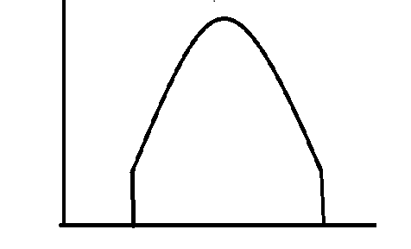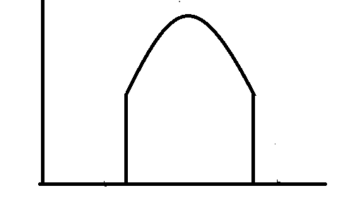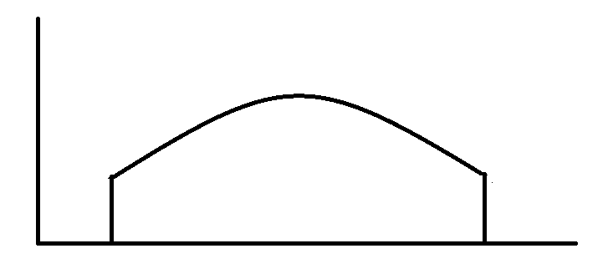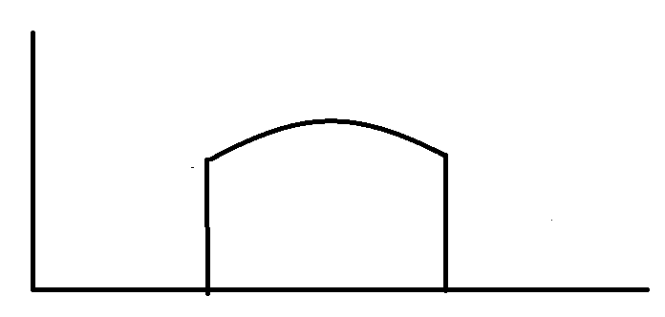

High Low

High t*

Low t*

α

z-z’

Figure 2

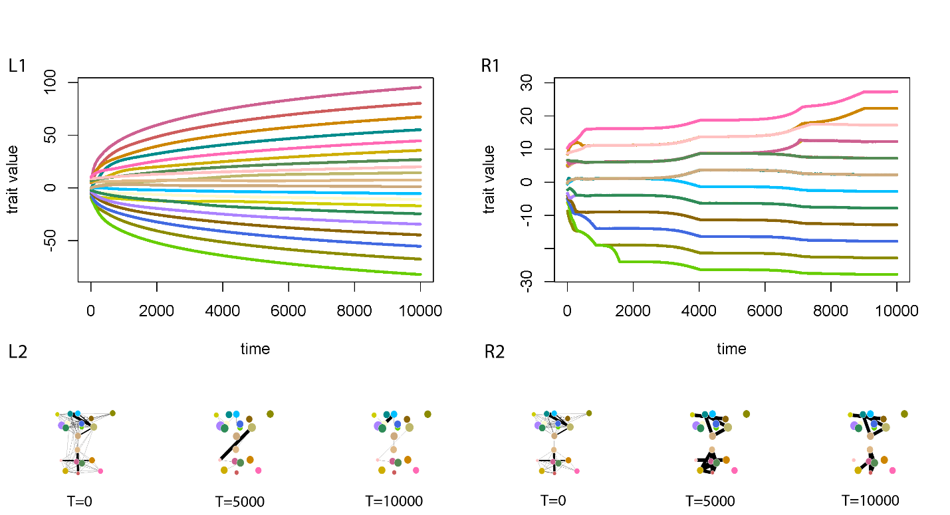

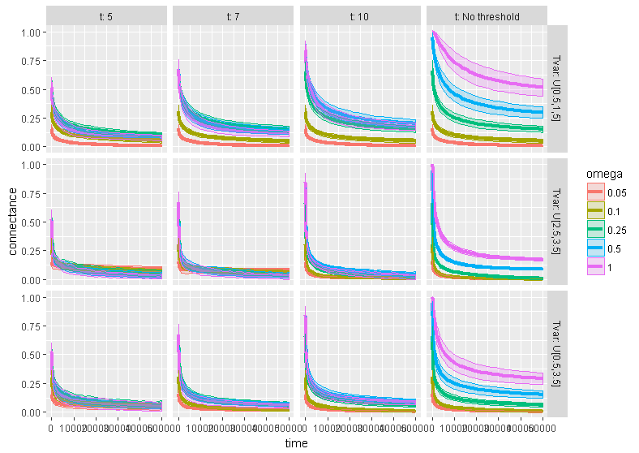Figure 3

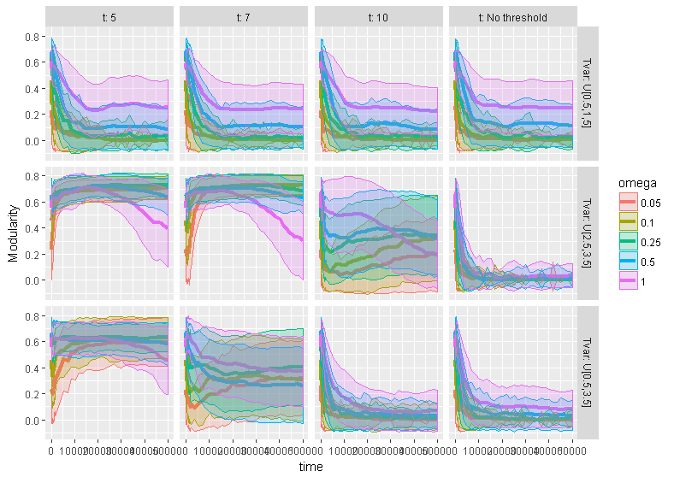Figure 4

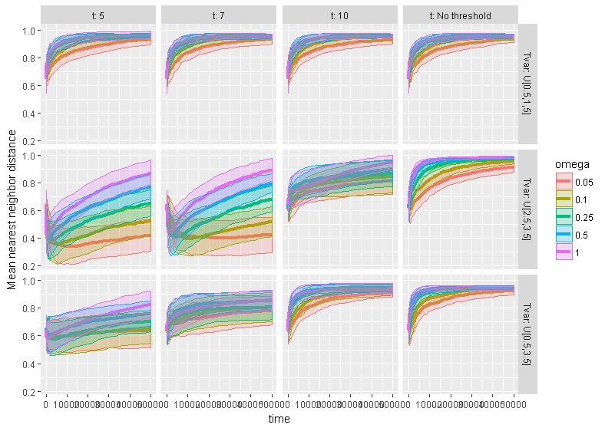Figure 5

Figure 6

